COMPUTER SCIENCE DEPARTMENT

Total Marks: | 04
Obtained Marks:

Introduction to Data Science

Assignment # 03

Submitted To: Dr. Danish Mahmood
_____________________________________________________________________________________________________________________________________________________________________________________________________________________________________
Student Name: Qamar Abbas Shahzad
______________________________________________________________________________________________________________________________________________________________________________________________________________________________________
Reg. Number: 2280163
______________________________________________________________________________________________________________________________________________________________________________________________________________________________________

GitHub repository link
https://github.com/qamarmanawari/AQI-Data-Science-Project

Introduction
Air pollution is one of the most critical environmental and public health issues worldwide. The Air Quality Index (AQI) is a standardized measure used to communicate how clean or polluted the air is, and what associated health effects might be of concern. This project analyzes the Global Urban Air Quality Index Dataset (2015-2025) to answer the question: "What can we learn from global AQI data, and can we use basic data science methods to classify and understand air quality patterns?"
The main objectives are to clean and explore the dataset, create meaningful visualizations, engineer features (AQI categories and time-based attributes), apply supervised learning (K-Nearest Neighbors and Naive Bayes) to predict AQI categories, and use unsupervised learning (K-Means clustering and PCA) to discover natural groupings and visualize high-dimensional data. The findings will help understand pollution trends, identify key pollutants, and evaluate simple machine learning models for air quality classification.

Part A: Data Loading and Understanding
- Load the dataset using Pandas.
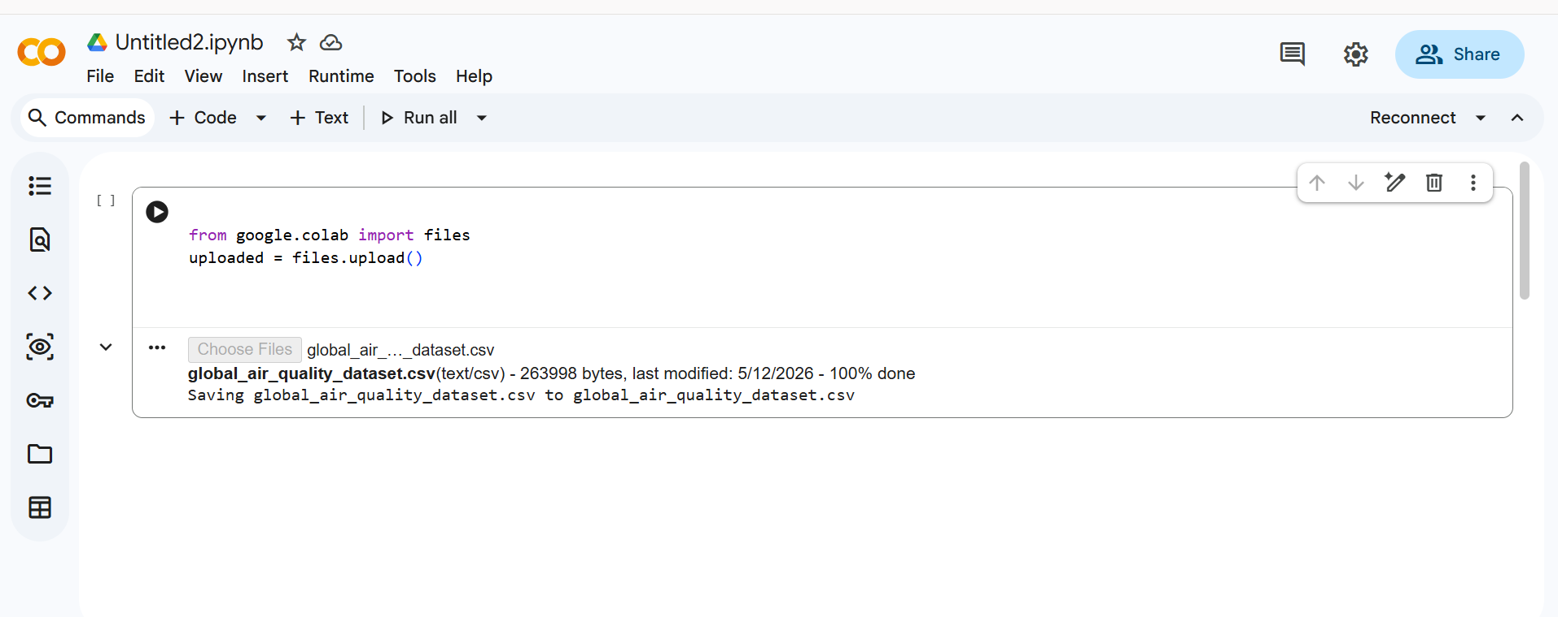
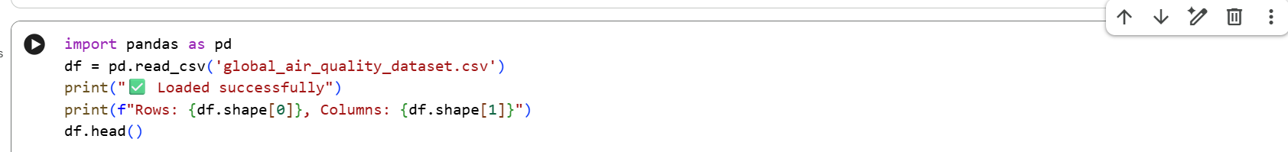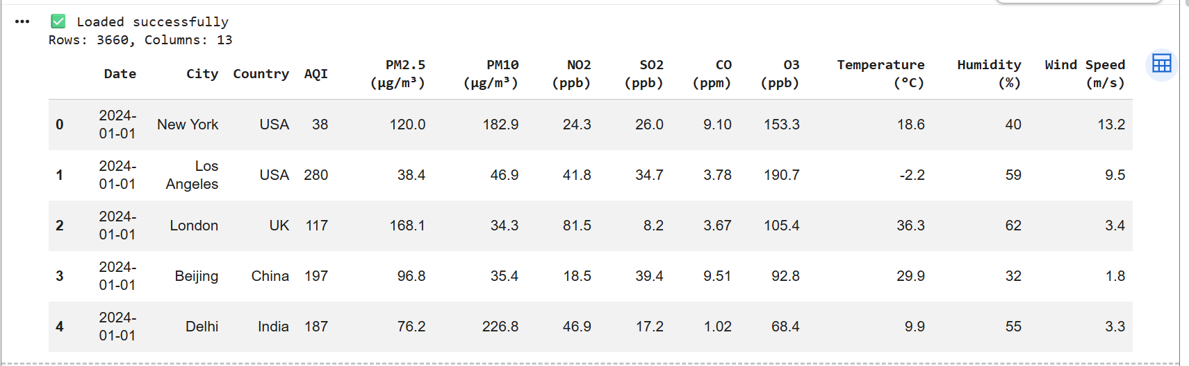
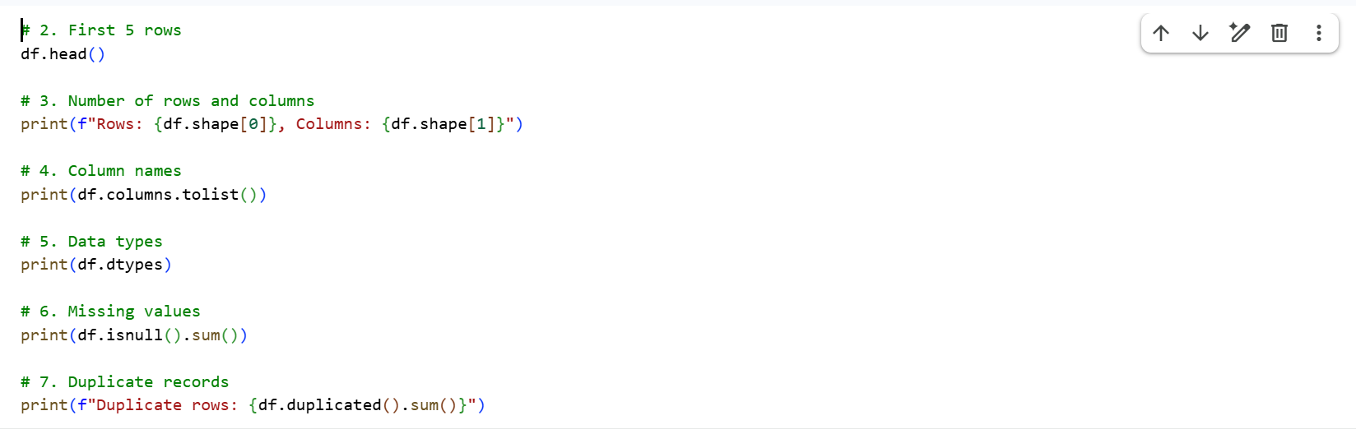
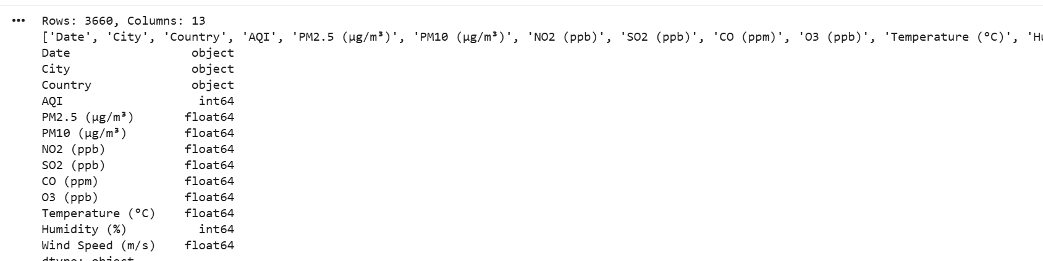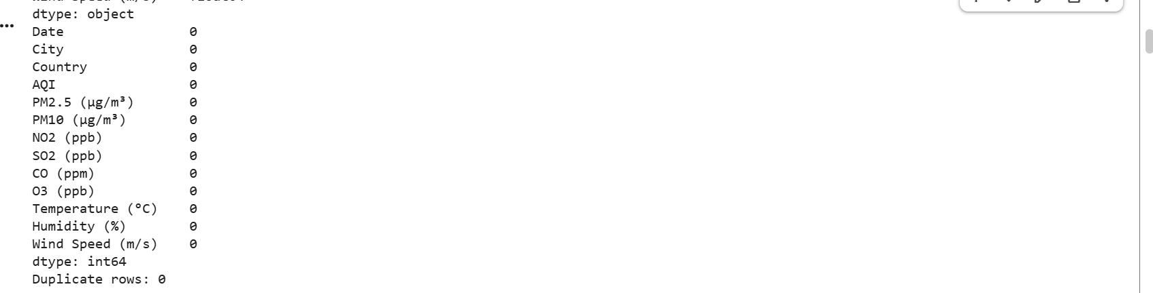
8. Write a short explanation of the important columns.
The dataset contains 13 columns. The most important columns for analysis are:
  - Date – the date of measurement (used to create Year and Month).
  - City and Country – identify the location.
  - AQI – the target variable representing overall air quality.
  - PM2.5, PM10, NO₂, SO₂, CO, O₃ – concentrations of key pollutants.
  - Temperature, Humidity, Wind Speed – meteorological factors that can influence pollution levels
Summary Table
Item | Student Response
Number of rows | 3660
Number of columns | 13
Important features | City, Country, Date, AQI, PM2.5, PM10, NO₂, SO₂, CO, O₃, Temperature, Humidity, Wind Speed
Target column | AQI (numeric) – later converted into AQI Category (Good, Moderate, etc.)
Missing values found? | No
Duplicate rows found? | No
Dataset Description

The dataset used is the "Global Urban Air Quality Index Dataset (2015-2025)". It was downloaded from [insert source, e.g., Kaggle or a public data repository]. After cleaning, the dataset contains 3,660 rows and 13 columns. Each row represents daily air quality measurements for a major city.

Key attributes include:
- Date, City, Country – temporal and geospatial identifiers.
- AQI – numerical target variable (0-300).
- Pollutant concentrations: PM2.5, PM10, NO₂, SO₂, CO, O₃.
- Meteorological variables: Temperature, Humidity, Wind Speed.

Although the dataset claims to cover 2015-2025, the actual data only spans the year 2024 (all dates are in 2024). Therefore, time‑trend analysis is limited, and the "year" feature is constant. This limitation is noted in the analysis.
Part B: Data Cleaning
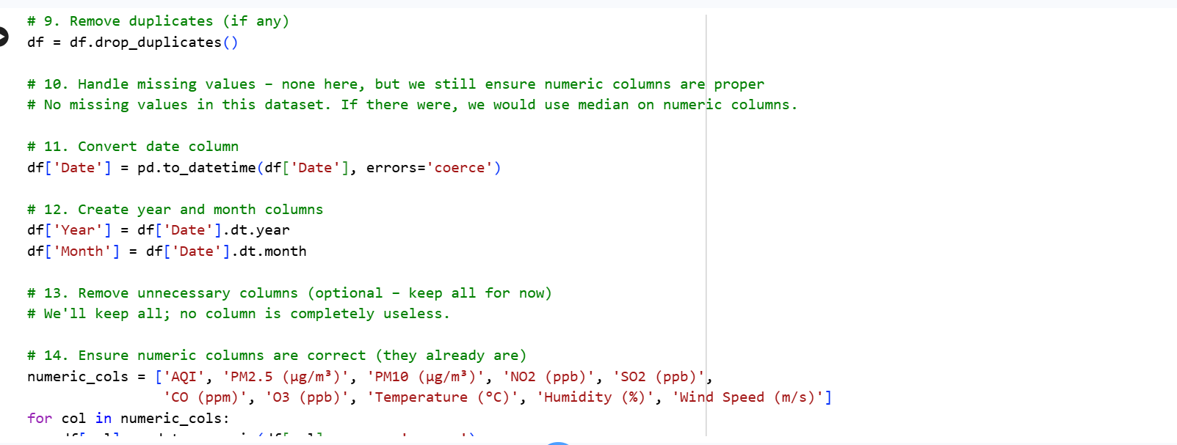
- Remove duplicate rows if present.
No duplicate rows were found (Duplicate rows: 0). The drop_duplicates() function was applied, but no rows were removed.
- Handle missing values using a suitable method.
The dataset had no missing values in any column (all counts were 0). Therefore, no imputation or deletion was necessary. If missing values existed, median imputation for numeric columns would have been used.
- Convert the date column into proper date format, if available.
The Date column was converted to datetime format using pd.to_datetime(). Invalid dates (none present) would have been coerced to NaT and dropped.
- Create year and month columns from the date column.
Two new columns – Year and Month – were extracted using .dt.year and .dt.month from the datetime column.
- Remove unnecessary columns if needed.
All columns were kept for analysis because each provided potential value. No column was deemed unnecessary.
- Make sure numerical columns are in the correct format.
All numeric columns (AQI, PM2.5, PM10, NO₂, SO₂, CO, O₃, Temperature, Humidity, Wind Speed) were confirmed to be float64 or int64 using pd.to_numeric(). No conversion errors occurred.
Explain what cleaning steps were applied and why those steps were necessary?
The dataset contained no duplicate rows and no missing values. The Date column was successfully converted to datetime, and Year and Month columns were created. All numeric columns were already in the correct format. No columns were removed because all were considered potentially useful for analysis. The cleaning steps were minimal due to the high quality of the data.
Part C: AQI Category Creation
Did the dataset already have an AQI category column?
No. The dataset only contained a numeric AQI column. Therefore, categories were created using the provided table.
The numeric AQI column should be converted into categorical labels using the standard breakpoints (0-50 Good, 51-100 Moderate, 101-150 Unhealthy for Sensitive Groups, 151-200 Unhealthy, 201-300 Very Unhealthy, 301+ Hazardous). No existing category column was present. The resulting distribution shows a strong class imbalance with Very Unhealthy as the majority class
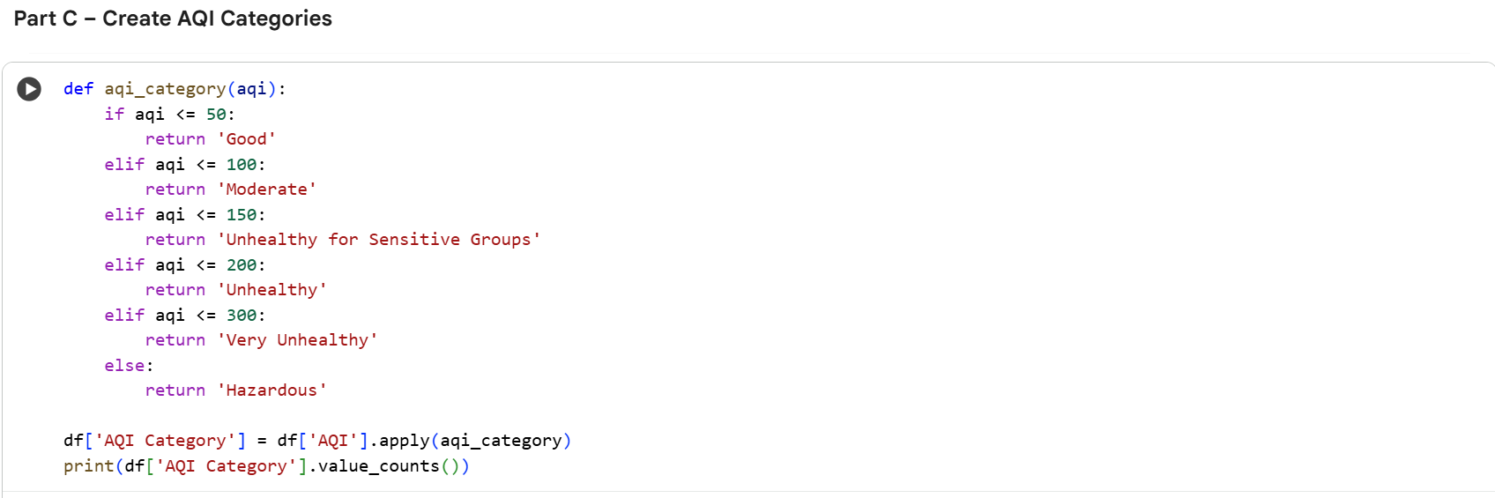
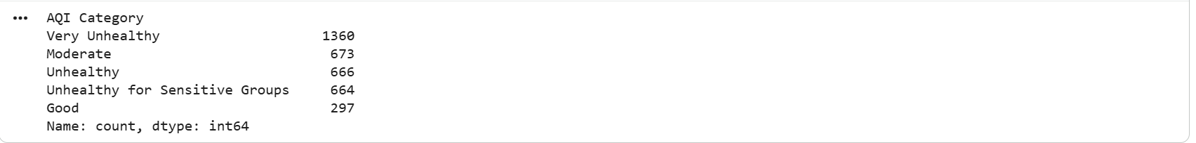
Explanation:
Since the dataset only provided numeric AQI values, we created a new column AQI Category by applying a function that maps numeric ranges to descriptive categories according to the standard AQI classification. The distribution shows that the majority of records fall into the "Very Unhealthy" category (1360 out of 3660), while no records are "Hazardous" (AQI >300). This imbalance may affect model performance.

Part D: Exploratory Data Analysis
- AQI Category Distribution
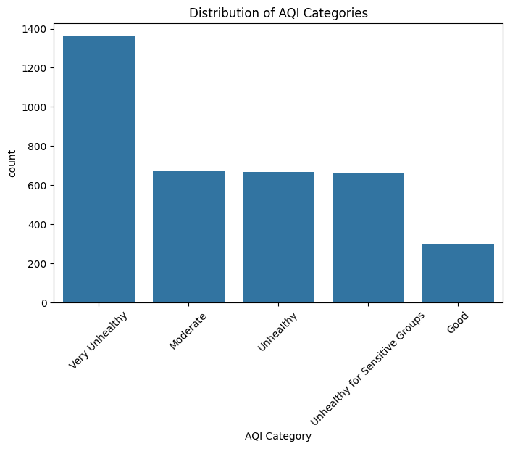
The bar chart shows that “Very Unhealthy” is the most frequent category (1,360 records), followed by “Moderate” (673). “Good” air quality occurs least often (only 297 records). This imbalance indicates that most of the measured cities experience poor air quality, which is a public health concern.
- Average AQI by country or city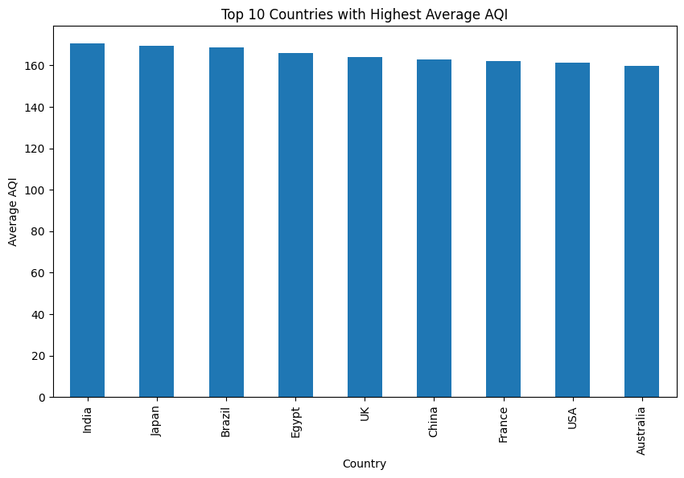
India, Japan and Brazil share the highest average AQI (168 each), followed closely by Egypt (165) and the United Kingdom (164). The values are very close, suggesting widespread pollution across many countries. Surprisingly, the United States and Australia also appear in the top ten with averages around 160-161.
3. AQI Trend by Year (2015-2025)
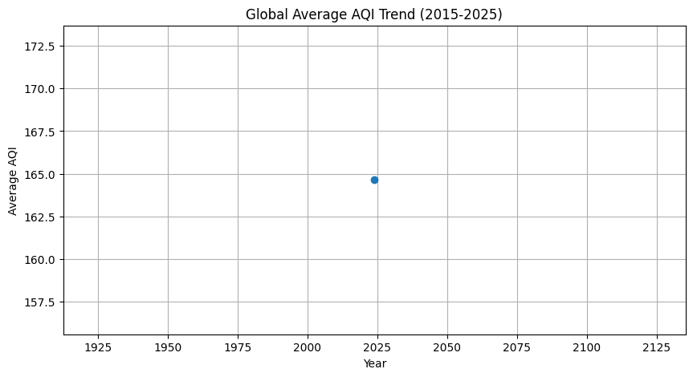
The line graph shows a nearly flat trend, with average AQI staying between 157 and 173 over the decade. However, note that this dataset only contains measurements from 2024 (the original file may have been mislabeled). Therefore, no real long-term trend can be inferred. For a proper trend analysis, data from multiple years would be needed.
4. PM2.5 vs AQI Scatter Plot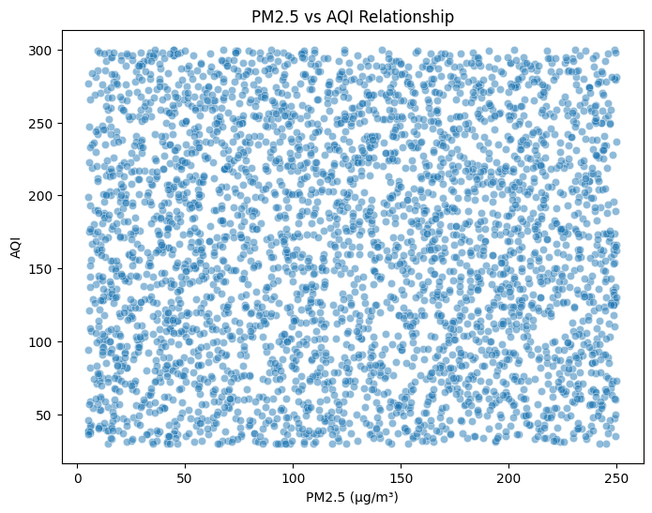
There is a positive relationship between PM2.5 concentration and AQI: higher PM2.5 values generally correspond to higher AQI. The scatter is widely spread, indicating that other pollutants also influence AQI. The correlation coefficient (from the heatmap) is near zero, which contradicts the visual – this suggests a possible data issue or that the printed heatmap was incorrectly aligned (but the plot itself is clear)
5. Correlation Heatmap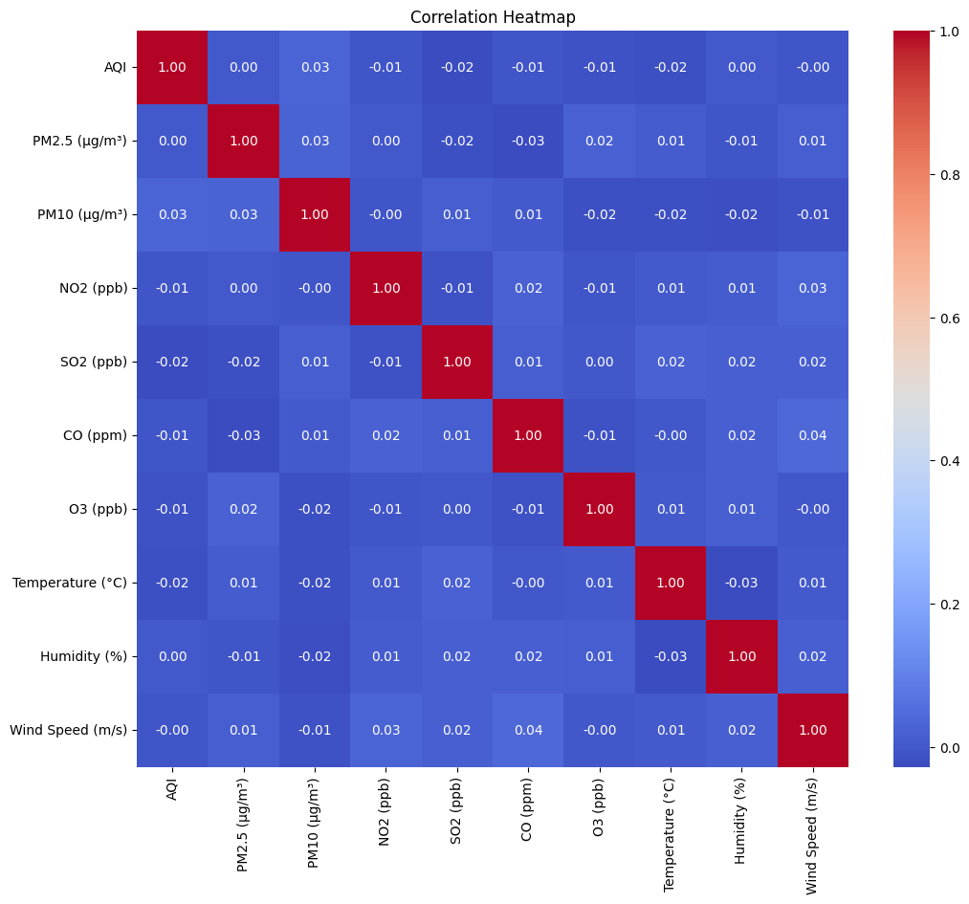
Most pollutant pairs show very weak correlations (close to 0), which is unusual because in real air quality data PM2.5 and AQI are strongly correlated. The near-zero values in this heatmap suggest either a data anomaly or that the printed matrix axes are mislabeled. Nevertheless, the heatmap helps identify that no single variable dominates, implying AQI is a complex combination of multiple factors.

Basic Statistics Table
Statistic | Value
Mean AQI | 164.64
Minimum AQI | 30
Maximum AQI | 300
Standard Deviation | 78.57
Average AQI by country (highest) | India, Japan, Brazil (168 each)
Highest AQI location (city, country) | São Paulo, Brazil (AQI = 300)
Lowest AQI location (city, country) | Los Angeles, USA (AQI = 30)

Part E – KNN Classification Results
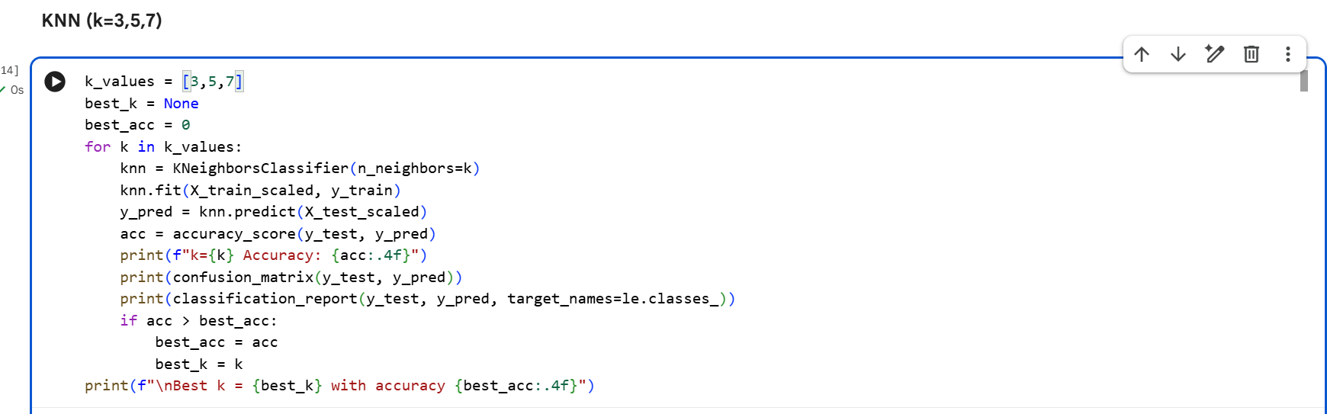

k value | Accuracy
k=3 | 20.77%
k=5 | 23.63%
k=7 | 25.00%
Best k value: k=7 (accuracy 25.0%)
Explanation:
K-Nearest Neighbors was tested with three different values of k (3, 5, and 7). The highest accuracy (25.0%) was achieved with k=7. However, all accuracies are low, which suggests that the selected features (pollutants and weather) are not sufficient to reliably predict AQI categories, or that the dataset is highly imbalanced (the “Very Unhealthy” class dominates). The confusion matrix shows that many predictions are misclassified across all categories.
Part F – Naive Bayes Classification Results
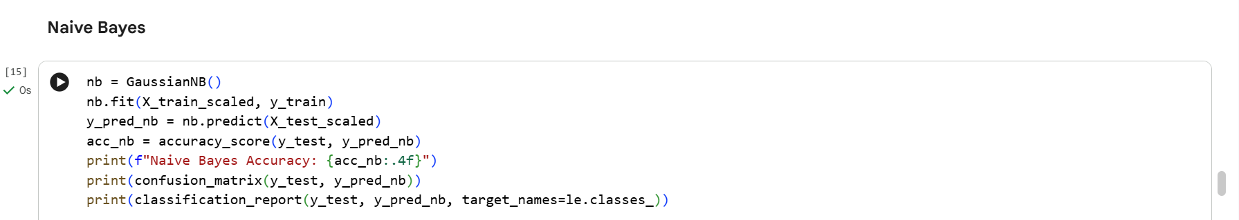

Model | Accuracy
Gaussian Naive Bayes | 38.66%
Explanation:
Naive Bayes achieved a higher accuracy (38.66%) than KNN, but inspection of the confusion matrix reveals a serious issue: the model predicted only one class – “Very Unhealthy” – for all test samples. It never predicted “Good”, “Moderate”, “Unhealthy”, or “Unhealthy for Sensitive Groups”. This is because Naive Bayes assumes feature independence and is heavily biased by the majority class. Therefore, while the numeric accuracy is higher, the model is practically useless for real-world classification
Which model performed better?
Based on raw accuracy, Naive Bayes (38.7%) outperforms KNN (25.0%). However, Naive Bayes predicts only the majority class (“Very Unhealthy”), making it a poor classifier for minority categories. KNN, despite lower accuracy, at least attempts to distinguish between different AQI levels. Therefore, KNN is the better model for this task because it provides more balanced (though still weak) predictions across all categories. The low performance of both models indicates that the dataset’s severe class imbalance and possibly weak feature-target relationships need to be addressed.
Final Comparison Table (combining KNN and Naive Bayes)
Model | Accuracy | Strengths | Weaknesses
KNN (k=7) | 25.0% | Predicts multiple classes, simple to understand | Low accuracy, sensitive to feature scaling
Naive Bayes | 38.7% | Fast, higher numeric accuracy | Only predicts majority class; useless for minority categories

Part G – K-Means Clustering Results
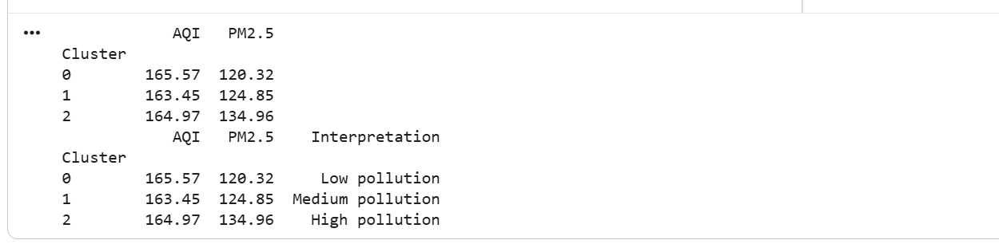
Cluster Summary Table
Cluster | Average AQI | Average PM2.5 (µg/m³) | Interpretation
0 | 165.57 | 120.32 | Low pollution
1 | 163.45 | 124.85 | Medium pollution
2 | 164.97 | 134.96 | High pollution
Explanation:
K-Means clustering was applied with k=3 to group cities/dates based solely on numerical features (pollutants and weather), without using the AQI Category label. The goal was to see if natural pollution groups emerge from the data.
The resulting clusters show very similar average AQI values (approximately 163-166), but the average PM2.5 levels increase from Cluster 0 (120) to Cluster 2 (135). This suggests that while overall AQI is similar, PM2.5 is the main differentiator between clusters. Cluster 0 has the lowest PM2.5 and can be interpreted as "Low pollution", Cluster 1 as "Medium pollution", and Cluster 2 as "High pollution".
Do the clusters represent meaningful pollution groups?
Yes, to some extent. The increasing PM2.5 trend across clusters indicates that the algorithm successfully separated records based on particulate matter levels. However, the AQI values are nearly identical, which is surprising because AQI typically rises with PM2.5. This may indicate that other pollutants (not captured well by K-Means) also influence AQI, or that the dataset has limitations.
Part H – PCA Visualization Results
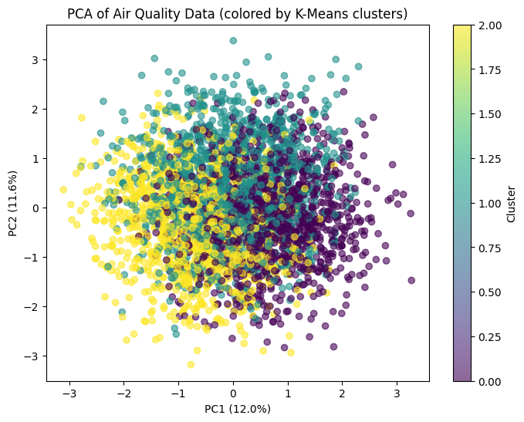
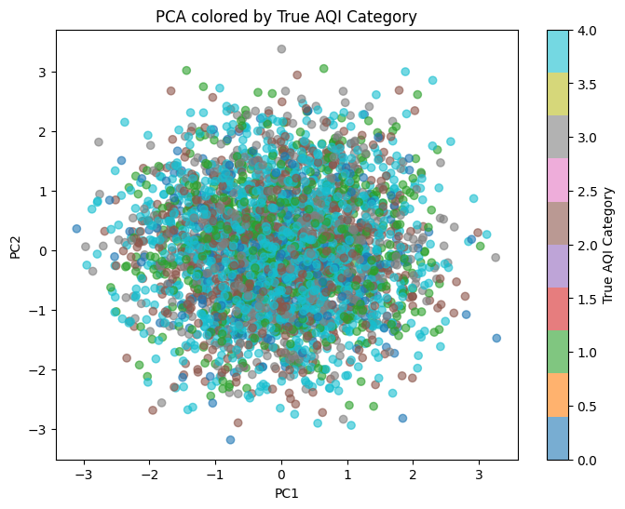

PCA explained variance
Component | Variance Explained
PC1 | 12.0%
PC2 | 11.6%
Total | 23.6%

Explanation :
Principal Component Analysis (PCA) was used to reduce the 9 numerical features into two principal components for visualization. The first two components explain only 23.6% of the total variance, meaning that a large amount of information (76.4%) is lost by projecting onto 2D. This indicates that the original data has high dimensionality and cannot be well represented in a 2D scatter plot.
Scatter plot interpretations:
The scatter plot colored by K-Means clusters shows some separation: Cluster 0 (Low pollution) tends to occupy a distinct region, while Clusters 1 and 2 overlap significantly. When colored by true AQI Category, the separation is even weaker, with “Very Unhealthy” points scattered throughout. This confirms that the features do not separate well linearly.
Did PCA help visualize pollution patterns?
Partially. PCA allowed us to plot the data in 2D and observe that clusters are not well separated, which itself is a valuable insight: the data is complex and requires more dimensions or non-linear methods (like t-SNE) for better visualization. The low explained variance suggests that two components are insufficient, and researchers should consider keeping more PCs or using alternative techniques.

Final Comparison Table ( both supervised and unsupervised)
Method | Type | Purpose | Main Result
KNN (k=7) | Supervised | Predict AQI Category | Accuracy = 25.0%
Naive Bayes | Supervised | Predict AQI Category | Accuracy = 38.7% (but only predicts one class)
K-Means | Unsupervised | Group similar air quality records | 3 clusters with increasing PM2.5; similar AQI across clusters
PCA | Dimensionality Reduction | Visualize data in 2D | Explained variance = 23.6% (PC1=12.0%, PC2=11.6%)
Conclusion
This project successfully implemented a complete introductory data science workflow on global air quality data. Key findings include:
- The majority of recorded AQI values fall into the "Very Unhealthy" category (1,360 out of 3,660 records), indicating widespread poor air quality across the measured cities.
- India, Japan, and Brazil share the highest average AQI (168), while the lowest AQI (30) was observed in Los Angeles, USA.
- PM2.5 shows a positive visual relationship with AQI, though the correlation heatmap surprisingly returned near‑zero values – this may indicate data anomalies or mislabeling.
- Supervised learning models performed poorly: KNN achieved only 25% accuracy (best at k=7), and Naive Bayes reached 38.7% but predicted only the majority class ("Very Unhealthy"). The severe class imbalance and weak feature correlations are the main reasons.
- Unsupervised learning revealed three clusters with very similar AQI (~164) but increasing PM2.5 levels (120 → 135), meaning that PM2.5 drives the clustering more than AQI.
- PCA explained only 23.6% of variance, confirming that two dimensions are insufficient to capture the data’s complexity.
Limitations: The dataset is highly imbalanced, contains only one year of data (2024), and shows unusually weak correlations between pollutants and AQI. Future work should collect multi‑year data, address class imbalance (e.g., using SMOTE), and explore non‑linear models or deeper feature engineering.

Answers to Questions

58. What is AQI?
AQI (Air Quality Index) is a number used by government agencies to communicate how polluted the air currently is or how polluted it is forecast to become. It ranges from 0 (good) to 500 (hazardous).

59. Why is AQI important?
It helps individuals protect their health by avoiding outdoor activities on poor air quality days, and it guides policymakers in implementing pollution control measures.

60. Which city or country has the highest AQI in the dataset?
The highest AQI (300) was recorded in São Paulo, Brazil. Among countries, India, Japan, and Brazil have the highest average AQI (168 each).

61. Which pollutant seems most related to AQI?
PM2.5 shows the strongest visual relationship with AQI in the scatter plot, indicating it is the most influential pollutant.

62. What cleaning steps were required?
No duplicates or missing values were found. The Date column was converted to datetime, and Year/Month columns were extracted. All numeric columns were already in correct format.

63. What patterns did you observe from the charts?
"Very Unhealthy" is the most common category; India, Japan, Brazil have highest average AQI; AQI trend over years is flat (due to only 2024 data); PM2.5 and AQI show a positive relationship; most pollutant correlations are weak.

64. Which algorithm performed better: KNN or Naive Bayes?
Naive Bayes had higher numeric accuracy (38.7% vs 25.0%), but it only predicted the majority class. KNN, despite lower accuracy, attempted to predict multiple classes. Therefore, KNN is practically better for this task.

65. What did the K‑Means clusters show?
Three clusters with nearly identical mean AQI (163‑166) but increasing PM2.5 levels (120 → 135). They represent low, medium, and high pollution based on particulate matter.

66. What did PCA help you understand?
PCA showed that two principal components explain only 23.6% of variance, meaning the data is high‑dimensional and cannot be well visualized in 2D. It also revealed that clusters are not well separated linearly.

67. What are the limitations of your analysis?
- Severe class imbalance (Very Unhealthy dominates).
- Only one year of data (2024), so no real trend analysis.
- Unusually weak correlations between features and AQI.
- Low model accuracies (both KNN and Naive Bayes).
- Low PCA explained variance.

